

**Secondary Payload Performance and Flight Considerations**

April 4th, 2023

The following report presents re-scaled attitude data from Vanderbilt’s February 18th full-scale launch alongside new data from the recent April 2nd launch. Videos of this new flight have been linked. The purpose of this report is to assuage concerns that VADL’s secondary payload, an altitude control system, is steering the launch vehicle.

First, the flight footage is presented at the following links:

* On Board Footage: <https://youtu.be/IJpQoHFYKF0>
* Ground Footage: <https://youtube.com/shorts/mOgepNrWvMs?feature=share>

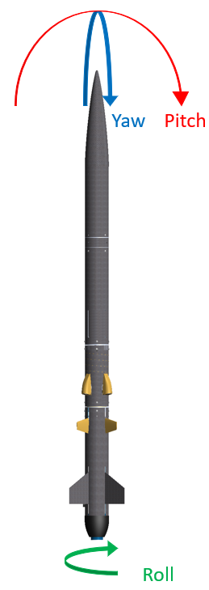

Figure 0. Definitions of attitude components.

In the FRR presentation, it was pointed out that Figure 1 did not scale the attitude data properly. Figure 2 shows an expanded view of the yaw and pitch with the time of AAC deployment noted. It is clear from Figure 2 that there is no discontinuity in the yaw or pitch at the instant of airfoil deployment.

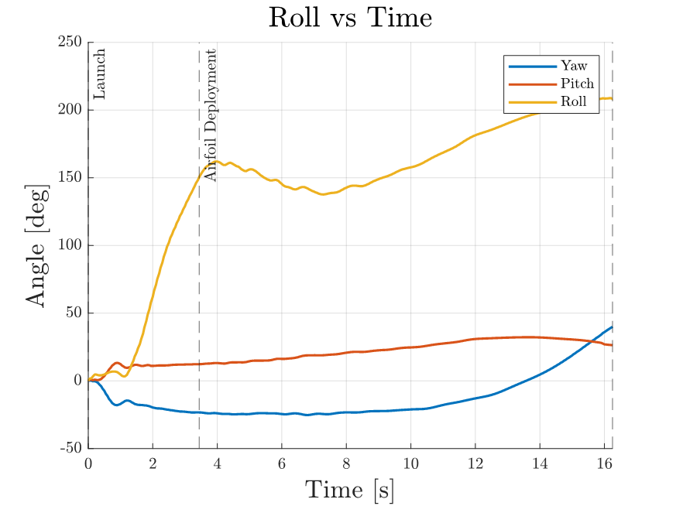

Figure 1. Attitude data presented in FRR (2/18 flight).

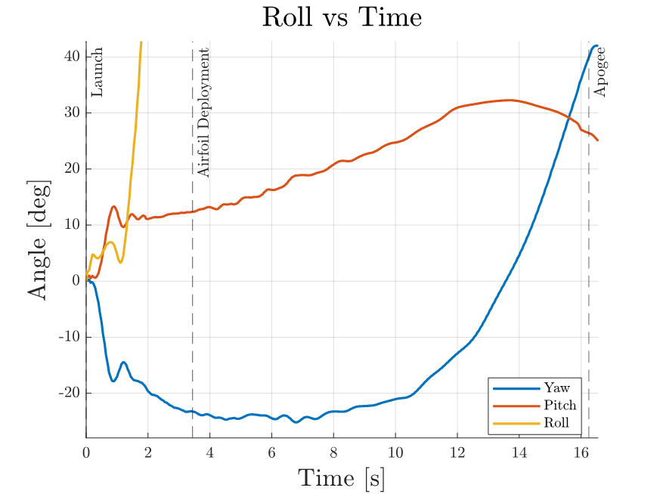

Figure 2. Zoomed view of yaw and pitch from Figure 1 (2/18 flight).

All of the above gyroscope data was obtained by integrating angular rate data into an angle. The IMU samples at a rate of 20 Hz. The 2/18 flight had deployed AAC in a drag configuration at 1250 ft.

VADL flew again on April 2nd. On this flight, AAC was deployed in the drag configuration at 2500 ft. Figure 3 presents the attitude components for this flight. Again, neither yaw nor pitch show any discontinuity at the instant of airfoil deployment.

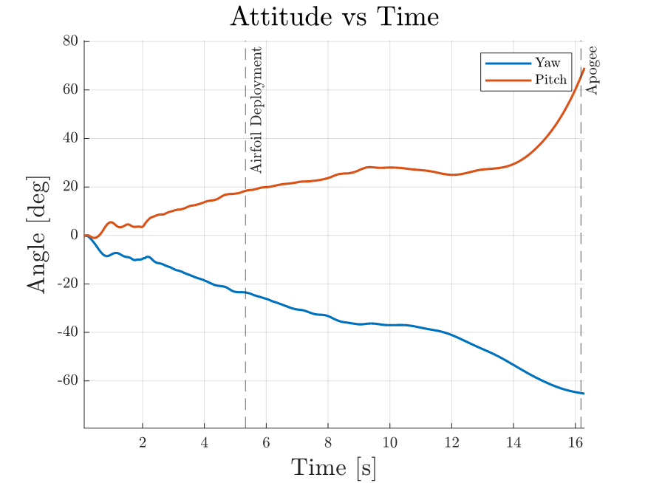

Figure 3. Yaw and pitch from 4/2 flight.

Figure 4 shows the roll data, on which AAC has no effect either.

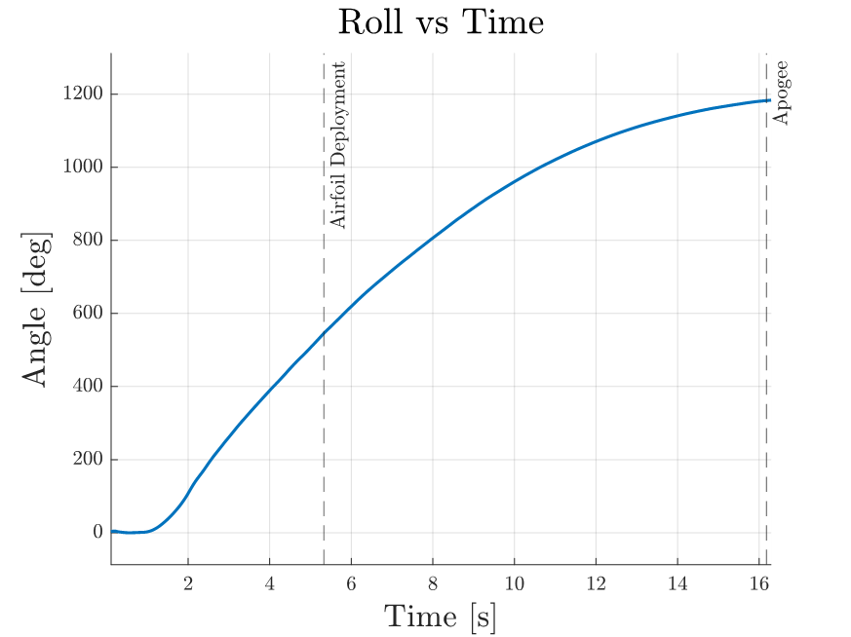

Figure 4. Roll data from 4/2 flight.

Finally, this flight also provided more data on the intended functionality of increasing drag. The same process presented in FRR was used to find the drag signature. Figure 5 shows the axial acceleration and Figure 6 shows the drag coefficient.

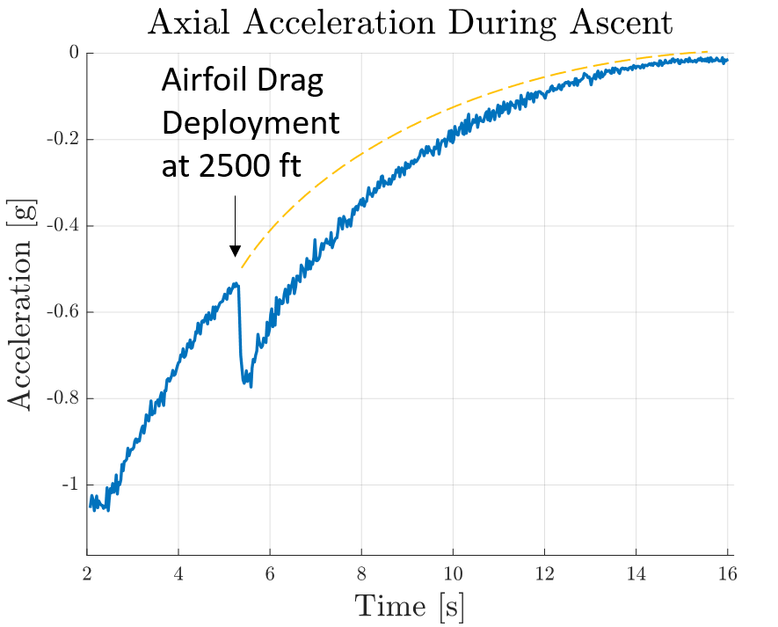

Figure 5. Axial acceleration during ascent on 4/2 flight.

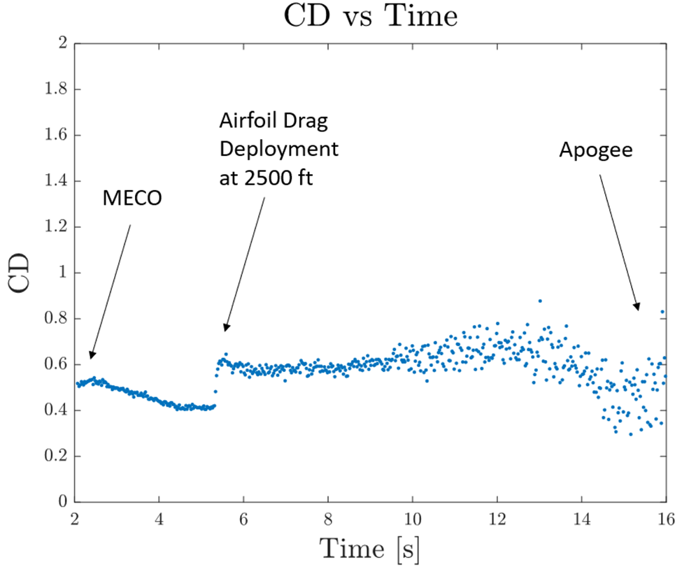

Figure 6. Drag coefficient during ascent on 4/2 flight.

The data again showed an increase in drag of around 50% at drag deployment, further bolstering confidence in the model.

Given the above presented data and the attached videos, VADL plans to fly AAC in its drag configuration. The AAC airfoils will be deployed either at 2500 ft or above. With two flights showing no effect on the vehicle attitude, VADL is confident that this secondary payload does not steer the rocket nor drastically affect the trajectory. The secondary payload only affects the drag coefficient and in no way steers the vehicle. VADL remains cognizant of the 4000 ft apogee minimum on launch day and does not consider AAC to hinder this requirement in any way.